Hormone administration / chemical alterations to endocrine state
For making oestrogens, progestogens or androgens

Preparation:
• Generally it is best to do these post-OVX/GDX of an animal to ensure gonadal steroids do not bias your hormone levels.
• Some labs will couple GDX with adrenalectomy to be certain, but I don't think that is horrifically necessary.
• Check the final concentration for what you need, rather than relying on the concentrations written above
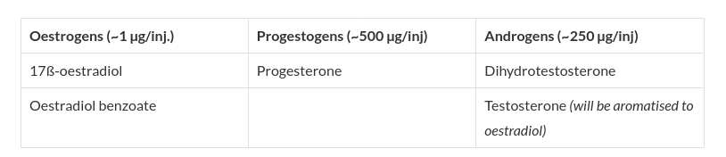
Making hormones:
• Hormones should be initially prepared as a 10X stock solution in either EtOH or DMSO (depending on the SDS sheet).
-- For oestrogens, make up a 100X stock rather than a 10X.
• Then, take 100 µL of the 10X stock and dilute in 900 µL of sesame oil for your working stock.

Example:
• For a final conc. of 500 µg/injection of progesterone, take 50 mg progesterone and dissolve in 1 mL DMSO.
• Take 100 µL of progesterone/DMSO and mix with 900 µL sesame oil.

Storage:
• Store all drugs, oils, and preparations at room temperature in a cool, dark space.
• 10X stocks will last for 2 months
• Oils should be used within a week.
• Do not store oils in the fridge/freezer or they will turn into margarine.

Injection:
• Take 100 µL of your 1X oil solution and inject it into the scruff of the mouse from the nose end.
• Aim to inject as close to just behind between the ears as possible (see image a)

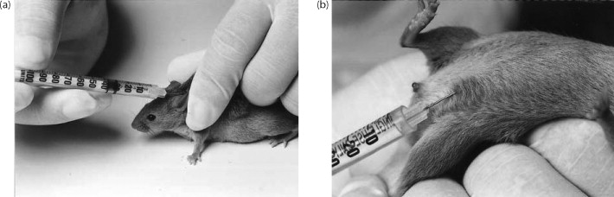

• The oil should be between the scapulae so movement causes the oil to dissipate.
• Repeated daily injections can alternate from scruff to inguinal skin (see image b).

LONGER TERM ALTERATIONS VIA SILASTIC IMPLANT
You will need:
• Silastic tubing: Dow-Corning 1 mm ID; 2.125 mm OD
• Silastic medical adhesive: Dow-Corning Silastic medical adhesive silicon Type A
• 10X hormone stock.
• Small Petri dish
• ~20G Needle
• 2x ~10cc Syringe

Method:
- Back fill your syringe with adhesive to 1.8 mL
- Push out 1.8 mL of glue into the Petri dish.
- Add 200 µL of your 10X Stock onto the glue
- Using a pipette tip mix together the glue and the stock solution until it becomes a shiny ball.
- Back fill a second syringe with your hormone/glue ball
- Put the needle on the syringe
- Place the tip of the needle into the tubing
- In one smooth motion (this will require a lot of force and effort and yelling), push the hormone/glue through into the tube.
- Do not stop once you start, absolutely no air bubbles should be in the glue in the tube.
- Leave your glue tubes covered to set (generally over night)

Implantation:
- Cut the tubing to 1 cm per 20 g mouse
- This will provide the equivalent of a 100 µL 1X oil solution injection.
- Following OVX/GDX insert blunt scissors subcutaneously and blunt dissect the fascia to form a pouch up the back of the animal
- Using long forceps, insert the tubing as far up towards the scapulae as possible
- Close the wound
- Hormones will release within 24 hours and last up to a week
- Generally I would suggest waiting to day 2 (assuming surgery is day 0) before using the animals to let them recover and hormones to be adequately released

